SOLUTION ARCHITECTURE:

1. Introduction
FitBuddy is a web-based application designed to generate personalized starter workout plans based on user-provided fitness information. The system combines a web interface, a Python backend, an AI integration layer, and a database to support fitness-plan generation, storage, retrieval, and feedback-based revision.
The solution architecture describes the interaction between these components and explains how information flows through the application.

2. Architectural Overview
FitBuddy follows a layered web application architecture consisting of the following components.

2.1 Presentation Layer
The presentation layer provides the user interface through HTML templates and CSS styling. Jinja2 is used to render dynamic HTML pages.
The main interface components include:
- base.html – shared page structure and layout.
- index.html – homepage and fitness information form.
- result.html – generated workout-plan display.
- all_users.html – administrative user-list interface.

2.2 Backend Application Layer
The backend is developed using Python and FastAPI. It handles incoming requests, coordinates application logic, communicates with the AI service and database, and returns the appropriate responses.
The main application modules are:
- main.py – initializes the FastAPI application and its associated components.
- routes.py – handles application routes and coordinates the relevant operations.
- schemas.py – defines data validation structures using Pydantic.

2.3 Artificial Intelligence Layer
The AI integration layer is implemented in ai_service.py. It connects the application to the configured Google Gemini service for generating workout recommendations, nutrition suggestions, and revisions based on user feedback.
The application also supports a demo-mode fallback when the AI service is unavailable or not configured. The fallback allows the application to demonstrate its supported workflow without depending entirely on a live AI response.

2.4 Database Layer
The database layer uses SQLite for local data storage and SQLAlchemy for database operations.
Its principal modules are:
- database.py – manages database configuration and connectivity.
- models.py – defines the database models used by the application.
The database supports the storage and retrieval of relevant user information and workout-plan records.

2.5 Configuration Layer
The config.py module manages application configuration. Environment variables can be used to supply sensitive settings, including the Gemini API key, without embedding the secret directly in the source code.

3. Solution Architecture Diagram
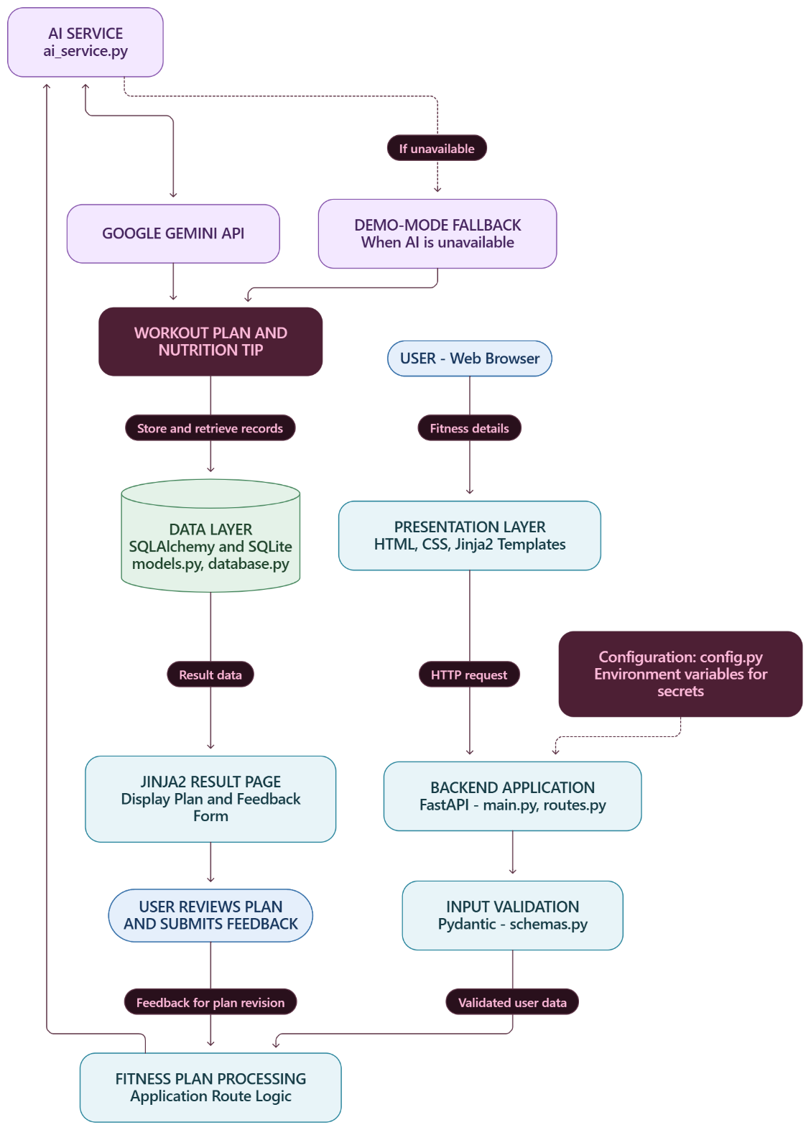

4. Working of the Solution Architecture

Step 1: User Interaction
The user opens the FitBuddy website through a web browser and accesses the fitness-planning form.

Step 2: Data Collection
The user enters a name, user ID, age, weight, fitness goal, and preferred workout intensity.

Step 3: Request Processing
The submitted form data is received by the FastAPI application. The backend processes the request and applies the relevant input validation.

Step 4: AI-Based Plan Generation
The application coordinates the fitness-plan generation process through its AI service. When the Gemini integration is available, it is used to generate workout recommendations and a general nutrition suggestion based on the submitted information.

Step 5: Fallback Handling
If the Gemini service is unavailable or not configured, the application can use its demo-mode fallback. This supports demonstration of the application's workflow without requiring a successful live AI response.

Step 6: Database Operations
Relevant user information and workout-plan records are managed using SQLAlchemy and SQLite. Stored information can be retrieved through the application's supported routes.

Step 7: Result Presentation
The backend returns the appropriate response, and Jinja2 renders the result page. The user can review the generated workout plan and its associated information.

Step 8: Feedback and Plan Revision
The user can submit feedback describing requested adjustments to the plan. The application processes this feedback and attempts to generate a revised plan through the available AI service or its configured fallback behaviour.

5. Data Management and Security
The architecture incorporates the following considerations:
- Input validation helps ensure that submitted information follows the application's defined requirements.
- SQLite provides local database storage for relevant application records.
- SQLAlchemy provides an organized method for interacting with the database.
- Environment configuration helps prevent API keys from being hardcoded into application source files.
- Administrative routes should be accessed according to the protection mechanisms implemented in the application.
- Generated fitness recommendations are intended as general guidance and should not be treated as medical advice.

6. Advantages of the Architecture
- Modularity: The interface, backend, AI integration, and database responsibilities are separated into distinct components.
- Maintainability: Individual modules can be modified with less need to change unrelated components.
- AI Integration: The application can use Gemini to generate fitness recommendations and respond to user feedback.
- Demonstration Support: The fallback mechanism can support demonstrations when the AI service is unavailable.
- Data Persistence: SQLite allows relevant records to be stored locally and retrieved later.
- Extensibility: The modular structure provides a foundation for adding features in future versions.

7. Conclusion
The FitBuddy solution architecture connects the web interface, FastAPI backend, Gemini integration, and SQLite database to provide a structured fitness-plan generation workflow. The separation of application components supports development, testing, maintenance, and future improvements while enabling users to generate starter workout plans and request adjustments based on their preferences.

